COS225 Assignment #3 Name: Nicholas Soucy

Part I. (20 pts) Enter answers into your document; please do not include this document.

1. An ______________ would be written to process code when a button is clicked.

c. event handler object

2. When a button is clicked, the _____________ event type occurs.

a. ActionEvent

3. Which statement is not true about inner classes?

d. Variables declared within the inner class may be accessed by the enclosing class.

4. The following code is an example of ______________.

btnNext.setOnAction (new EventHandler<ActionEvent>( ) {
public void handle(ActionEvent e) {System.out.println "Hello"); } });

b. anonymous inner class

5. The ____________ method is used to read the return the content of text within a TextField control.

a. getText

6. Use the _______________ animation to make a circle move around the outline of a polygon.

a. PathTransition

7. In order to move a ball downward by 5 pixels in its pane, the ______________.

c. y direction is increased by 5

8. Code that implements the EventHandler<ActionEvent> interface must implement the ___ method.

b. handle

Answer questions about the code below.

public class Question9 extends Application{
private int radius = 30; // circle radius
private int x = 100; // start x coordinate
private int y = 100; // start y coordinate

public void start (Stage primaryStage)
{ BorderPane bPane = new BorderPane( );
Button btnNext = new Button ("Next");
bPane.setTop(btnNext);
bPane.setPadding(new Insets(10,10,50,10));
Scene scene = new Scene (bPane, 500, 500);
primaryStage.setScene(scene);
primaryStage.show( );

btnNext.setOnAction(new EventHandler<ActionEvent>( ) {
@Override
public void handle(ActionEvent e) {
radius += 5; x+= 10; y += 10;
Circle c = new Circle(radius);
bPane.getChildren( ).add(c);
c.setCenterX(x);
c.setCenterY(y);
c.setFill(Color.PURPLE);
}});
} }

9. What is the visual output if the button is clicked ten times?

b. A purple eggplant shape is seen.

10. Would the code work correctly if the Circle c declaration was moved from the event handler to the top of the start method?

b. No
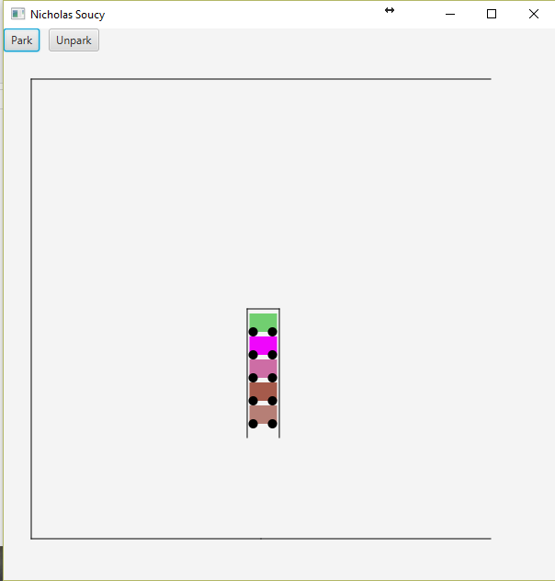
Part II. (80 pts.)

